Menu-Role-Access

An application that displays the contents of the menu bar based on the user’s role. A user depending on his role, will have access/be permitted only to certain functionalities. A user having the highest order of role will have access to all the functionalities but for someone from much lower order of role will only have access to few of them.

UI Requirements:

A menu bar on the top displaying mutiple tabs.



Each of the tabs have a drop-down box with a list of contents.

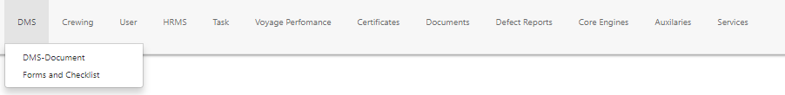

To keep menu-permission level check dynamic, added multiple buttons at the bottom of the page displaying all the user roles available in the DB. When clicked on the User Role, based on the permission level of that user, the menu contents are displayed.

